Coconut Panna cotta
9 x ½ cup Servings | 5 minutes Preparation | 3 Hours Total Time
Ingredients  600ml Full Fat Cream  400ml Coconut Milk  1/4 cup (60gm) of Honey  4 Leaves of Gelatin softened in water OR 4 tsp of powdered gelatin dissolved in ¼ cup of boiling water | 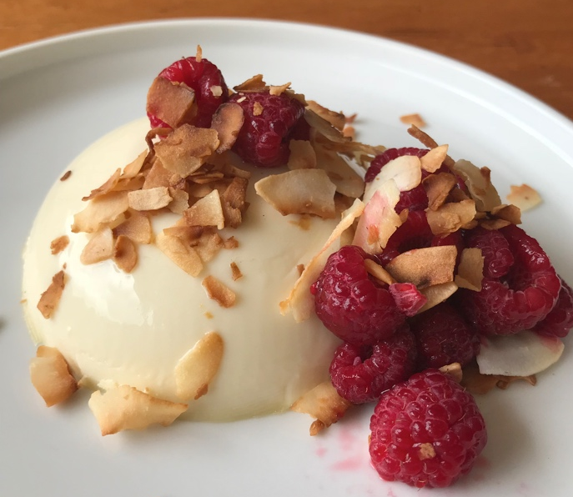

Directions
Place all ingredients except gelatin in the Thermomix and set at 80 degrees, speed 3, for 4 minutes. Add gelatin and mix at speed 4 for 10 seconds
Pour evenly into panna cotta moulds/small bowls or cups and leave in the fridge until set.
To serve, briefly immerse the mould in warm water and then invert the mould onto the serving plate.
Top with toasted shaved coconut and fresh berries.

Notes
This recipe is easily doubled and freezes up to 3 months.
To defrost – place in the fridge on a tray (still covered) 1 – 2 days before serving and allow it to come completely to fridge temperature before plating.
Add more honey if you like it sweeter.
Serve with lychees and lime syrup, fresh passionfruit, sliced mango and toasted coconut, or shaved chocolate. Your options are endless

